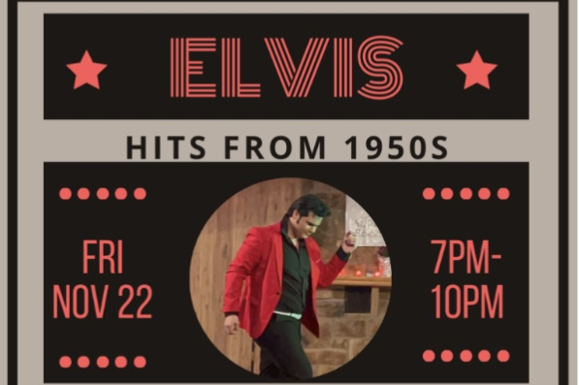

The Haddon Fortnightly
invites you to
Young Elvis Tribute Night
301 Kings Highway East, Haddonfield

Bring friends for lots of laughs!

$25 per person ticket includes
Shamrock Deli delights at 7pm
Elvis Tribute Artist, Benjamin D’s Show at 8pm
BYOB, a Bake Sale & more!

For tickets: contact Sue Foley
at susanfoley43@yahoo.com or 773/679-8142

