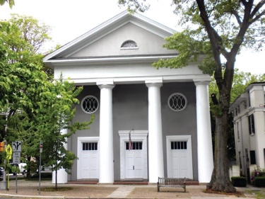
The Haddon Fortnightly Women’s Club
invites you to enter a
Greeting Card Cover Contest

Create a drawing (pencil, crayon, ink, or paint) for our greeting card cover.
Two categories: Holiday and Kindness
Winners for K-2, 3-5 and 6-8th grade groups will be recognized.
Gift certificates awarded to winners of each category.

Cards sold by The Haddon Fortnightly, a nonprofit local service organization, as a fundraiser and available via their website and/or Facebook page.

Entries should be 8.5 x 11-inches and mailed in a large envelope to:
The Haddon Fortnightly, 301 Kings Hway E, Haddonfield, NJ 08033
Attention: Card Contest. -OR- drop at the Haddonfield or Haddon Township Libraries no later than Friday, October 26. Multiple entries accepted
Entries must include the completed permission slip below

I ___________________________________ give permission for the artwork
Print name of Parent or legal guardian

of my student ________________________________ to be used for
Print name of Student

The Haddon Fortnightly’s Greeting Card. I agree that he/she may appear in publications including local newspaper and the Haddon Fortnightly website and Facebook Page along with said artwork.

______________________________________ ________________
Signature of Parent or legal guardian Date

__________________________________________________________
Phone number and/or email to contact Parent or legal guardian.

